**PROJECT REPORT**

**CYBERSECURITY**

**WIRELESS NETWORK SECURITY ASSESSMENT**



**TEAM DETAILS**

**TEAM ID : LTVIP2023TMID07732**

**TEAM MEMBERS**

**TEAM LEADER: KOTAPATI VENKATA THRILOK**

|  |  |  |
| --- | --- | --- |
| **Roll Number** | **Name** | **Email** |
| 20KH1A0446 | Kotapati Venkata Thrilok | thrilokkotapati@gmail.com |
| 20KH1A0425 | Chittem Venkat | 2020ece.r25@svck.edu.in |
| 20KH1A0415 | Badimala Bharathkumar | bharath4031@gmail.com |
| 20KH1A0476 | Putta Eshakshay | eshakshay@gmail.com |

**WIRELESS NETWORK SECURITY ASSESSMENT**



**Information Gathering**

Wireless networks ease the connectivity within the organization and increase the flexibility of working for the employees. This also increases the security risk associated with the wireless network which serve as a potential attack surface.

Wireless security assessment helps identify vulnerabilities and security risks in the wireless network. Our Security Consultants test for different vulnerabilities and perform different test cases to identify vulnerabilities in the wireless network. These vulnerabilities can be induced because of misconfigured wireless accesspoint, vulnerabilities in the Wireless Access point's firmware or the encryption and authentication methods for example WPA or WPA2.

### Email Footprint Analysis:

### Email footprint analysis is a technique used to collect information about an individual or organization by analyzing their email communications. This can include analyzing the email headers, email addresses, and email content to gather information such as the sender IP address, email service providers, and communication patterns. This technique can be useful in threat intelligence, social engineering, and other cyber investigations.

### Email footprint analysis in wireless network security refers to the process of examining email-related activities and data exchanged within a wireless network to identify potential security risks and vulnerabilities. This analysis helps in understanding the scope of email communication within the wireless network and assessing the potential impact of email-related threats. Here are the key points covered in this analysis:

### Email Traffic Analysis:

### Examination of email traffic within the wireless network to identify patterns, volume, and sources of emails.

### Understanding the frequency and nature of email exchanges to assess normal behavior.

### Email Content Analysis:

### Scanning email content to detect potential phishing attempts, malicious attachments, or suspicious links.

### Identifying sensitive information leaks or unauthorized data transfers via email.

### Email Security Controls:

### Reviewing existing email security measures, such as spam filters, antivirus, and encryption.

### Evaluating the effectiveness of these controls in detecting and preventing email-based threats.

### Email Authentication:

### Analyzing the implementation of email authentication protocols (SPF, DKIM, DMARC) to prevent email spoofing and impersonation attacks.

### Email Access and Usage:

### Examining the access points and devices used to access emails within the wireless network.

### Assessing user practices and compliance with security policies related to email usage.

### Email Server Configuration:

### Reviewing the email server settings and configurations for vulnerabilities or misconfigurations.

### Checking for open relay or other configuration issues that may lead to abuse.

### Email Archiving and Retention:

### Verifying the presence of an email archiving system and adherence to data retention policies.

### Ensuring compliance with legal and regulatory requirements.

### Email Incident History:

### Investigating any past email-related security incidents or breaches and learning from them.

### Identifying trends or recurring patterns that need attention.

### Email Encryption:

### Evaluating the use of email encryption for sensitive communications.

### Assessing the strength and implementation of encryption protocols.

### Email User Awareness:

### Assessing the level of user awareness about email security best practices, phishing awareness, and social engineering threats.

### 

### The email footprint analysis in wireless network security helps organizations identify potential weaknesses and areas of improvement related to email security. The insights gained from this analysis can guide the implementation of stronger security measures, user training, and overall risk mitigation strategies to protect sensitive information and prevent email-based threats.

### DNS Information Gathering

### 

### DNS (Domain Name System) information gathering in wireless network security involves the process of collecting and analyzing DNS-related data to understand the network’s domain infrastructure, identify potential vulnerabilities, and detect suspicious activities. Here are the key aspects of DNS information gathering in wireless network security:

### DNS Enumeration:

### Enumerating DNS records to identify all associated domain names, subdomains, and IP addresses within the wireless network.

### Verifying the correctness of DNS entries and identifying any inconsistencies or misconfigurations.

### DNS Zone Transfers:

### Checking for open DNS zone transfers that could potentially leak sensitive information about the network’s internal structure to attackers.

### Reverse DNS Lookups:

### Performing reverse DNS lookups to associate IP addresses with domain names, allowing the identification of potential misconfigurations or suspicious hosts.

### DNSSEC (DNS Security Extensions) Analysis:

### Assessing whether DNSSEC is implemented and properly configured to prevent DNS data manipulation attacks like DNS cache poisoning.

### DNS Cache Analysis:

### Analyzing the DNS cache to detect any unauthorized or potentially malicious entries, which could indicate DNS spoofing or cache poisoning attempts.

### DNS Traffic Analysis:

### Monitoring DNS traffic to identify anomalies, unusual query patterns, or excessive query volumes, which could indicate suspicious or malicious activities.

### DNS Resolvers and Servers:

### Identifying the DNS resolvers and authoritative servers used within the wireless network and ensuring they are secure and up-to-date.

### DNS Filtering and Blacklisting:

### Assessing the effectiveness of DNS filtering and blacklisting mechanisms in place to block access to malicious or phishing domains.

### DNS Health and Performance:

### Checking for DNS server health and performance to ensure DNS services are running smoothly and capable of handling legitimate traffic.

### Domain Reputation:

### Analyzing the reputation of domains associated with the wireless network to identify potential malicious domains or those flagged for abuse.

### 

### DNS information gathering in wireless network security is a crucial step in understanding the network’s domain infrastructure and potential security risks. The insights gained from this analysis can help in strengthening DNS security measures, ensuring the integrity of DNS services, and preventing DNS-related attacks and unauthorized access. Regular monitoring and maintenance of DNS infrastructure are essential to maintain a secure and reliable wireless network environment.

### WHOIS Information Gathering:

### WHOIS information gathering involves gathering information about the owner of a domain name, IP address, or autonomous system number (ASN). This information can include the owner name, contact details, and registration dates. This technique can be useful in identifying the owners of malicious or suspicious domains.

In wireless network security, “Whois” information gathering can be relevant when investigating potential security incidents or identifying the ownership and registration details of wireless access points (Aps) and associated devices. However, it’s important to note that the traditional Whois database mainly contains information about domain names and IP addresses, which may not directly apply to wireless network devices.

In the context of wireless network security, “Whois” information gathering can involve the following:

1. Access Point Information:

- Retrieving information about wireless access points, such as the manufacturer, model, and firmware version, to identify potential vulnerabilities or known security issues.

2. MAC Address Lookup:

- Conducting MAC address lookups to determine the vendor of the wireless network device, which can aid in identifying the manufacturer of the wireless equipment.

3. Wireless Network Owner Identification:

- Identifying the organization or individual associated with a specific wireless network to understand its purpose and potential security implications.

4. Network Registration:

- Verifying the registration details of the wireless network with relevant regulatory authorities (e.g., FCC in the United States) to ensure compliance with legal requirements.

5. Network Contact Information:

- Obtaining contact information for the owner or administrator of the wireless network in case of security incidents or unauthorized access.

6. DNS Information:

- Investigating DNS records associated with the wireless network or related services to gather more information about the network infrastructure.

It’s essential to highlight that “Whois” information gathering in wireless network security may not provide the same level of detail as traditional domain name or IP address Whois queries. The availability of information may also vary depending on the type of wireless network and its registration with regulatory bodies.

For more comprehensive wireless network security assessments, additional techniques such as wireless network scanning, packet capturing, and vulnerability assessments are typically performed to identify potential security risks, unauthorized devices, and security weaknesses.

### 

**Information Gathering For Social Engineering Attacks**

Social engineering attacks involve manipulating individuals to divulge sensitive information or perform certain actions. Information gathering for social engineering attacks involves researching the target personal and professional information, communication patterns, and behavior to craft effective social engineering attacks.



Social engineering attacks are a type of cyber attack that relies on human interaction to trick victims into giving up their personal information or taking actions that compromise their security. Social engineers use a variety of techniques to manipulate their victims, such as:

Phishing:

Phishing is the most common type of social engineering attack. It involves sending emails or text messages that appear to be from a legitimate source, such as a bank or credit card company. The emails or text messages will often contain a link that, when clicked, will take the victim to a fake website that looks like the real website. Once the victim enters their personal information on the fake website, the social engineer can steal it.

Pretexting:

Pretexting is a type of social engineering attack in which the attacker creates a false scenario in order to gain the victim’s trust. For example, the attacker might pose as a customer service representative from a company and call the victim, claiming that there is a problem with their account. The attacker will then ask the victim for personal information, such as their Social Security number or credit card number, in order to “fix” the problem.

Baiting:

Baiting is a type of social engineering attack in which the attacker leaves a lure, such as a USB drive or a piece of paper with a link on it, in a public place. The victim is then tricked into picking up the lure and opening the link, which can install malware on their computer.

Quid pro quo:

Quid pro quo attacks are a type of social engineering attack in which the attacker offers the victim something in exchange for their personal information. For example, the attacker might pose as a survey researcher and offer the victim a gift card in exchange for their participation in the survey. However, the survey is actually a way for the attacker to collect personal information from the victim.

Tailgating:

Tailgating is a type of social engineering attack in which the attacker follows an authorized person into a secure area. The attacker will often pretend to be a delivery person or a contractor in order to gain access.

Social engineering attacks can be very effective because they exploit human nature. People are often more likely to trust someone they know, even if they don’t know them very well. They are also more likely to be helpful and cooperative, especially if they think they are helping someone in authority.

There are a number of things that individuals and organizations can do to protect themselves from social engineering attacks. These include:

Be suspicious of emails and text messages from unknown senders. Don’t click on links or open attachments in emails or text messages unless you are sure that they are from a legitimate source.

Be careful about giving out personal information over the phone or in person. Only give out personal information if you are sure that the person you are talking to is who they say they are.

Be aware of the signs of a social engineering attack. If someone is asking you for personal information that you don’t feel comfortable giving, or if they are trying to pressure you into taking a certain action, be suspicious.

Educate your employees about social engineering attacks. Make sure that your employees know how to identify and avoid social engineering attacks.

By being aware of the risks and taking steps to protect themselves, individuals and organizations can help to reduce their chances of becoming victims of social engineering attacks.

**Emerging Trends And Technologies In Information Gathering:**

Information gathering is a constantly evolving field with new trends and technologies emerging all the time. Some emerging trends and technologies in information gathering include the use of machine learning and artificial intelligence to automate data analysis, the increasing use of open-source intelligence (OSINT) tools, and the use of big data analytics to identify patterns and trends.

As of my last update in September 2021, some emerging trends and technologies in information gathering included:

1. Artificial Intelligence and Machine Learning: AI-powered algorithms enable more efficient data analysis, pattern recognition, and predictive insights, enhancing information gathering capabilities.

2. Internet of Things (IoT): IoT devices are becoming increasingly prevalent, providing a vast amount of real-time data from various sources, which can be used for information gathering purposes.

3. Big Data Analytics: Advanced analytics tools help process massive datasets quickly, uncovering valuable information and trends that were previously challenging to identify.

4. Blockchain Technology: Blockchain's decentralized and tamper-resistant nature is being explored for secure data gathering, especially in industries like finance and supply chain management.

5. Augmented Reality (AR) and Virtual Reality (VR): These technologies enable immersive data visualization and enhanced situational awareness for information gathering in various fields.

6. Social Media Analytics: The growing popularity of social media platforms offers valuable data for understanding trends, sentiment analysis, and public opinions.

7. Geospatial Analysis: Integration of geographic information systems (GIS) with various data sources aids in location-based information gathering and analysis.

8. Quantum Computing: While still in the early stages, quantum computing holds the potential to revolutionize information gathering by processing vast amounts of data exponentially faster.

Please note that technology evolves rapidly, and there might be newer developments beyond my knowledge cutoff date. I recommend keeping up-to-date with the latest information sources for the most recent trends and technologies in information gathering.



**Vulnerability Identification**

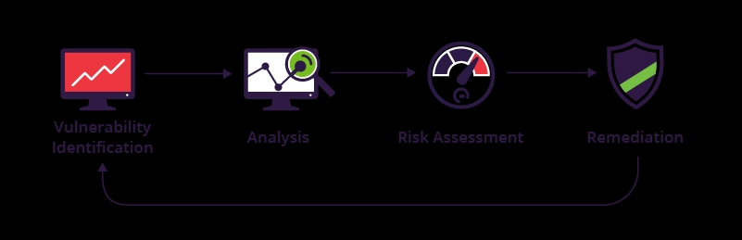

A vulnerability assessment is a systematic review of security weaknesses in an information system. It evaluates if the system is susceptible to any known vulnerabilities, assigns severity levels to those vulnerabilities, and recommends remediation or mitigation, if and whenever needed.

Examples of threats that can be prevented by vulnerability assessment include:

1. SQL injection, XSS and other code injection attacks.
2. Escalation of privileges due to faulty authentication mechanisms.
3. Insecure defaults – software that ships with insecure settings, such as a guessable admin passwords.

There are several types of vulnerability assessments. These include:

1. **Host assessment** – The assessment of critical servers, which may be vulnerable to attacks if not adequately tested or not generated from a tested machine image.
2. **Network and wireless assessment** – The assessment of policies and practices to prevent unauthorized access to private or public networks and network-accessible resources.
3. **Database assessment** – The assessment of databases or big data systems for vulnerabilities and misconfigurations, identifying rogue databases or insecure dev/test environments, and classifying sensitive data across an organization’s infrastructure.
4. **Application scans** – The identifying of security vulnerabilities in web applications and their source code by automated scans on the front-end or static/dynamic analysis of source code

Identify And Name Each Vulnerability

Understanding and defining vulnerabilities involves identifying potential weaknesses and flaws in an application’s design or implementation. This process involves reviewing the application’s code and functionality to identify any areas that could potentially be exploited by an attacker. Once a vulnerability has been identified, it must be defined and classified based on its severity and potential impact on the application’s security.

To identify and name vulnerabilities, you typically follow these steps:

1. **Vulnerability Assessment**: Conduct a vulnerability assessment using various tools and techniques. Automated vulnerability scanners, manual inspections, and penetration testing are common methods.
2. **Review Security Advisories**: Stay up-to-date with security advisories from vendors and software developers. These advisories often list identified vulnerabilities and their names.
3. **CVE Database**: Check the Common Vulnerabilities and Exposures (CVE) database, which catalogs publicly disclosed cybersecurity vulnerabilities. Each vulnerability in the database is assigned a unique identifier, such as “CVE-YYYY-XXXX.”
4. **NIST National Vulnerability Database (NVD)**: Refer to the NVD, a U.S. government repository that provides details about vulnerabilities and their impacts.
5. **Security Forums and Blogs**: Monitor security forums and blogs, where security researchers and professionals often share information about newly discovered vulnerabilities.
6. **Bug Bounty Programs**: If applicable, engage in bug bounty programs, where security researchers are rewarded for reporting vulnerabilities to the organization or software developer.
7. **Security Community**: Be an active part of the security community, participating in discussions, conferences, and workshops to learn about emerging vulnerabilities.
8. **Categorization**: Once a vulnerability is identified, it is categorized based on its type (e.g., SQL injection, buffer overflow, cross-site scripting) and severity (e.g., low, medium, high, critical).

Remember, it is essential to act responsibly and ethically when searching for vulnerabilities. Always seek permission from the system owners before conducting any testing.

### Assign A Common Weakness Enumeration (CWE) Code To Each Vulnerability

### 1. **CWE-89 (SQL Injection)**: This vulnerability occurs when untrusted data is directly included in SQL queries, allowing an attacker to manipulate the query and potentially gain unauthorized access to the database.

### 2. **CWE-79 (Cross-Site Scripting, XSS)**: XSS vulnerabilities enable attackers to inject malicious scripts into web pages viewed by other users, leading to potential data theft or session hijacking.

### 3. **CWE-78 (OS Command Injection)**: This vulnerability happens when untrusted data is used to construct operating system commands, allowing an attacker to execute arbitrary commands on the targeted system.

### 4. **CWE-306 (Missing Authentication for Critical Function)**: If an application fails to authenticate users properly for critical functions, attackers might gain unauthorized access and perform harmful actions.

### 5. **CWE-434 (Unrestricted Upload of File with Dangerous Type)**: Allowing users to upload files without proper validation may lead to the execution of malicious scripts or unauthorized access.

### 6. **CWE-310 (Cryptographic Issues)**: This category covers various weaknesses related to the incorrect or weak use of cryptography, such as insecure encryption algorithms or key management.

### 7. **CWE-311 (Missing Encryption of Sensitive Data)**: Storing sensitive data without encryption could expose it to unauthorized access or theft.

### 8. **CWE-601 (URL Redirection to Untrusted Site ('Open Redirect'))**: This vulnerability occurs when an application redirects users to an untrusted site, potentially leading to phishing attacks.

### Please note that real-world vulnerabilities might have multiple CWE codes or fall under different classifications depending on their specific characteristics. It's essential to refer to authoritative sources like the CWE database for the most accurate and up-to-date information.

### Provide Corresponding Open Web Application Security Project (OWASP) Category And Description For Each Vulnerability

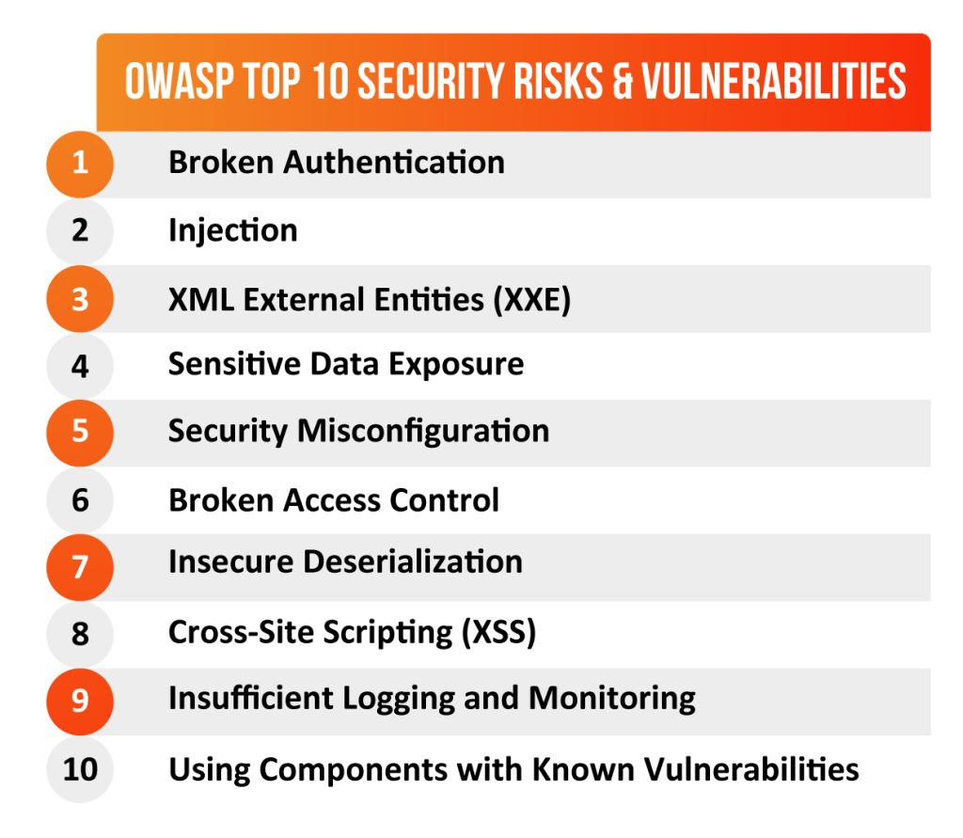

here are the corresponding Open Web Application Security Project (OWASP) categories and descriptions for the vulnerabilities mentioned earlier:

1. **CWE-89 (SQL Injection)**:

- OWASP Category: Injection

- Description: SQL Injection is an attack that allows an attacker to manipulate a web application’s SQL query through unvalidated user input. This can lead to unauthorized access to the database, data theft, or the ability to execute arbitrary commands.

2. **CWE-79 (Cross-Site Scripting, XSS)**:

- OWASP Category: Cross-Site Scripting (XSS)

- Description: Cross-Site Scripting occurs when an attacker injects malicious scripts into web pages viewed by other users. This vulnerability can enable the attacker to steal data, hijack user sessions, or perform other malicious actions.

3. **CWE-78 (OS Command Injection)**:

- OWASP Category: Injection

- Description: OS Command Injection occurs when untrusted data is used to construct operating system commands, allowing attackers to execute arbitrary commands on the targeted system.

4. **CWE-306 (Missing Authentication for Critical Function)**:

- OWASP Category: Broken Authentication

- Description: This vulnerability arises when an application fails to authenticate users properly for critical functions. Attackers can exploit this weakness to gain unauthorized access to sensitive parts of the application.

5. **CWE-434 (Unrestricted Upload of File with Dangerous Type)**:

- OWASP Category: Security Misconfiguration

- Description: Allowing users to upload files without proper validation can lead to the execution of malicious scripts or unauthorized access to the system.

6. **CWE-310 (Cryptographic Issues)**:

- OWASP Category: Cryptographic Failures

- Description: This category covers various weaknesses related to the incorrect or weak use of cryptography, such as insecure encryption algorithms or key management.

7. **CWE-311 (Missing Encryption of Sensitive Data)**:

- OWASP Category: Sensitive Data Exposure

- Description: Storing sensitive data without encryption could expose it to unauthorized access or theft.

8. **CWE-601 (URL Redirection to Untrusted Site (‘Open Redirect’))**:

- OWASP Category: Unvalidated Redirects and Forwards

- Description: This vulnerability occurs when an application redirects users to an untrusted site, potentially leading to phishing attacks or other malicious actions.

Remember that OWASP categories are broader classifications, and many vulnerabilities may fall under multiple categories. It’s essential to thoroughly understand each vulnerability and its potential impact to implement effective security measures.

**Understanding And Defining Vulnerabilities**

Understanding and defining vulnerabilities is a critical first step in identifying and mitigating potential risks in an application. A vulnerability can be defined as a flaw or weakness in the system that can be exploited by attackers to compromise the security of the system. Vulnerabilities can exist in different layers of the application, including the network layer, application layer, and the database layer. By understanding the different types of vulnerabilities that exist, developers and security professionals can take appropriate measures to mitigate the risks and prevent attacks.

Vulnerabilities refer to weaknesses or flaws in a system or application that can be exploited by malicious actors to compromise its security or functionality. These weaknesses can range from software bugs and misconfigurations to design flaws and human errors. Understanding vulnerabilities involves identifying them, assessing their potential impact, and implementing measures to mitigate or eliminate the associated risks. Defining vulnerabilities involves providing specific details about the weaknesses, including their nature, location, and potential consequences. Regular vulnerability assessments and security updates are crucial to maintaining a secure and resilient system.

**Identifying And Naming Vulnerabilities**

Identifying and naming vulnerabilities is the next step in the vulnerability assessment process. This involves conducting a thorough analysis of the application to identify all potential vulnerabilities that could be exploited by attackers. Once identified, each vulnerability should be given a clear and concise name that accurately describes the nature of the vulnerability.

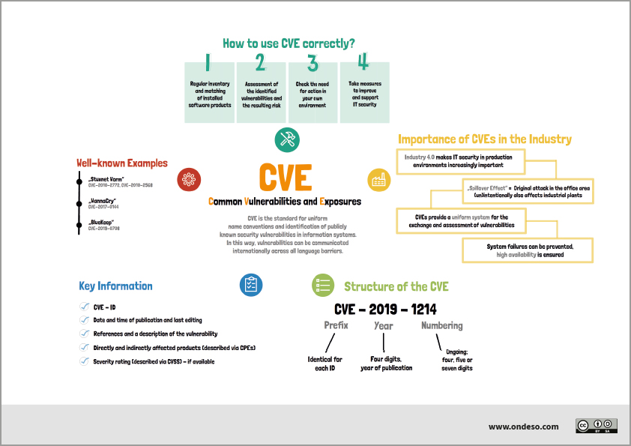

Identifying vulnerabilities involves various methods, including manual code review, security testing, and automated vulnerability scanners. Here are some common approaches:

1. Code Review: Skilled developers and security experts analyze the source code to identify potential vulnerabilities such as buffer overflows, injection flaws, or insecure access controls.
2. Penetration Testing: Ethical hackers simulate real-world attacks to find vulnerabilities in the system, network, or applications.
3. Vulnerability Scanners: Automated tools scan the system for known vulnerabilities, including outdated software versions and misconfigurations.
4. Security Bulletins and CVEs: Monitoring security advisories and Common Vulnerabilities and Exposures (CVE) databases helps to stay informed about known vulnerabilities and their names.

When naming vulnerabilities, the industry typically follows a standard convention, often using a CVE identifier. For example, “CVE-2023-12345” represents a specific vulnerability that was reported in the year 2023 and has a unique identifier. This naming convention helps in tracking and referencing vulnerabilities across different platforms and organizations.

**Assigning CWE Codes To Each Vulnerability**

**Assigning Common Weakness Enumeration (CWE) codes to each vulnerability is an important step in the vulnerability assessment process. CWE is a community-developed list of common software and hardware weaknesses, maintained by the MITRE Corporation, which provides a common language for identifying, understanding, and mitigating software vulnerabilities. By assigning a CWE code to each vulnerability, security professionals and developers can better understand the nature of the vulnerability and take appropriate steps to mitigate the risk.**

**Common Weakness Enumeration (CWE) is a community-developed list of common software security weaknesses. Each vulnerability can be assigned a unique CWE code to categorize and reference it. When assigning CWE codes to vulnerabilities, consider the following steps:**

**1. Identify the Vulnerability: Determine the specific vulnerability you want to categorize with a CWE code. This could be a result of your vulnerability assessment or security testing.**

**2. Consult CWE Database: Refer to the CWE database (https://cwe.mitre.org) to find the appropriate CWE code that best describes the identified vulnerability.**

**3. Review CWE Hierarchy: Understand the hierarchical structure of CWE to ensure you select the most granular and accurate CWE code.**

**4. Assign the CWE Code: Once you've found the suitable CWE code, apply it to the vulnerability documentation or report.**

**For example, if you identified a SQL injection vulnerability, you could assign the corresponding CWE code, such as "CWE-89" which specifically denotes "Improper Neutralization of Special Elements used in an SQL Command ('SQL Injection')."**

**By associating CWE codes with vulnerabilities, it becomes easier to communicate and share information about security weaknesses in a standardized manner.**

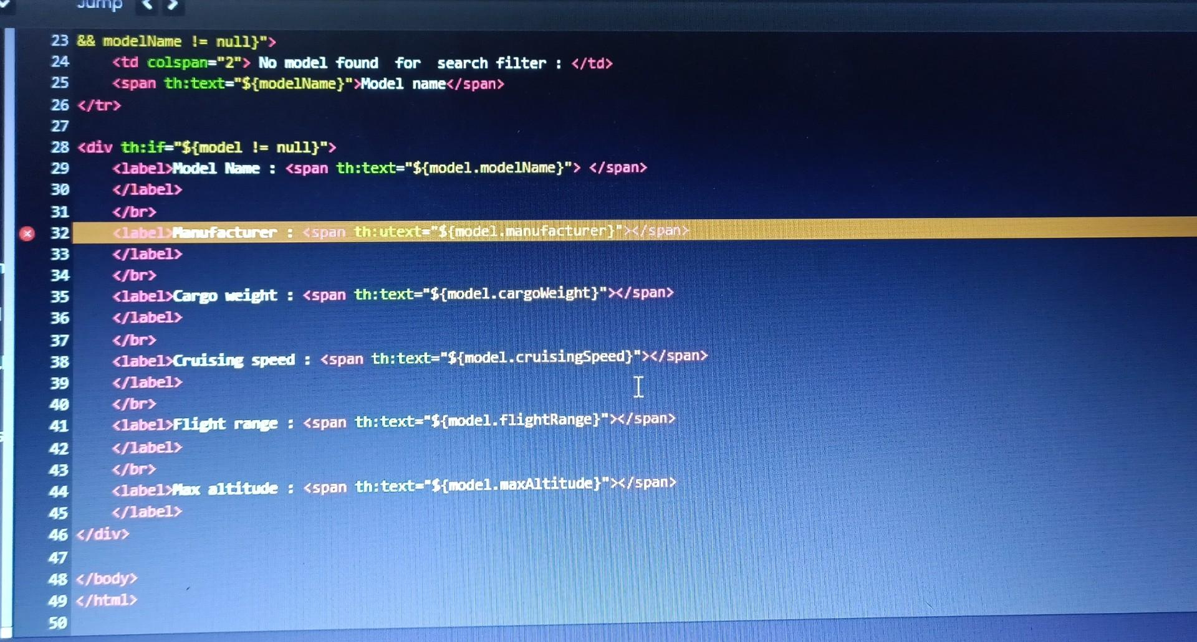

**Providing OWASP Category And Description For Each Vulnerability**

Providing OWASP category and description for each vulnerability involves categorizing the vulnerabilities based on the OWASP Top 10, which is a list of the most common web application vulnerabilities. This process involves identifying which OWASP category the vulnerability falls under and providing a detailed description of the vulnerability. This information is important because it helps developers and security professionals prioritize which vulnerabilities to address first, based on their potential impact on the application's security.

**As an AI language model, I don’t have direct access to external databases like OWASP (Open Web Application Security Project). Therefore, I don’t have a live list of vulnerabilities and their descriptions based on the latest OWASP guidelines.**

**However, I can provide you with some common OWASP categories and their brief descriptions, which are widely recognized in the cybersecurity community. For more detailed and up-to-date information, I recommend visiting the official OWASP website at** [**https://owasp.org**](https://owasp.org)**.**

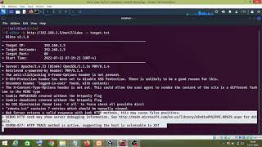

**1. OWASP Top Ten:**

**- Description: The OWASP Top Ten is a list of the ten most critical security risks to web applications, covering common vulnerabilities like injection attacks, broken authentication, sensitive data exposure, etc.**

**2. Cross-Site Scripting (XSS):**

**- Description: XSS allows attackers to inject malicious scripts into web pages viewed by other users, leading to data theft, session hijacking, or unauthorized actions.**

**3. SQL Injection:**

**- Description: SQL injection occurs when malicious SQL code is inserted into input fields, enabling attackers to manipulate or gain unauthorized access to a database.**

**4. Cross-Site Request Forgery (CSRF):**

**- Description: CSRF tricks users into performing unwanted actions on a different website while logged into an authenticated session, leading to unauthorized operations.**

**5. Broken Authentication and Session Management:**

**- Description: This vulnerability arises when authentication and session management mechanisms are poorly implemented, allowing attackers to compromise user accounts and sessions.**

**6. Security Misconfiguration:**

**- Description: Security misconfiguration happens due to improperly configured servers, databases, or applications, exposing sensitive information and increasing attack surface.**

**7. Insecure Direct Object References:**

**- Description: This occurs when an application exposes internal object references (e.g., file paths, database keys), allowing attackers to access unauthorized resources.**

**8. Cross-Site Script Inclusion (XSSI):**

**- Description: XSSI enables attackers to include malicious scripts into web pages, taking advantage of insecure cross-domain access policies.**

**9. Using Components with Known Vulnerabilities:**

**- Description: When applications use outdated or vulnerable components, attackers can exploit these known weaknesses to compromise the application.**

**10. Insufficient Logging and Monitoring:**

**- Description: Lack of proper logging and monitoring makes it difficult to detect and respond to security incidents, hindering timely incident response.**

**Please note that the OWASP Top Ten list is periodically updated, and new vulnerabilities may emerge. Always refer to the official OWASP website for the latest information and recommendations on application security.**

### Business Impact Assessment

### 

### Conduct A Thorough Analysis Of The Potential Business Impact Of Each Vulnerability

Conducting a business impact assessment is an important step in the vulnerability identification and reporting process. This involves analyzing the potential impact that each vulnerability could have on the organization&#39;s operations, reputation, and finances. The assessment should take into account the likelihood of the vulnerability being exploited, the potential damage that could be caused, and the organization&#39;s ability to respond and recover from such an incident. By conducting a thorough business impact assessment, stakeholders can prioritize the vulnerabilities and allocate resources appropriately to mitigate the risks.

As an AI language model, I don’t have access to your specific business environment, systems, or data. Conducting a thorough analysis of the potential business impact of each vulnerability requires a comprehensive understanding of your organization’s assets, processes, and risk appetite.

However, I can provide you with a general framework to help you assess the potential business impact of vulnerabilities:

1. Asset Identification: Identify the critical assets and resources in your business, such as customer data, intellectual property, financial systems, or production infrastructure.
2. Vulnerability Severity: Determine the severity of each vulnerability based on industry standards or security frameworks. Consider factors like ease of exploitation, potential damage, and affected assets.
3. Impact Scenarios: For each vulnerability, envision potential scenarios of how it could be exploited and the consequences it might lead to, such as data breaches, service disruptions, financial losses, or reputational damage.
4. Business Impact Assessment: Quantify the potential impact of each scenario in terms of financial losses, operational disruption, compliance violations, legal consequences, and damage to brand reputation.
5. Probability of Occurrence: Evaluate the likelihood of each scenario actually occurring, considering the current security controls and threat landscape.
6. Mitigation Efforts: Assess the effectiveness and cost of implementing security measures to mitigate or reduce the risk associated with each vulnerability.
7. Prioritization: Prioritize vulnerabilities based on their potential business impact and the resources required to address them. Focus on mitigating the most critical risks first.
8. Continuous Monitoring: Regularly review and update your vulnerability assessments as new threats emerge and your business environment evolves.

Remember, a comprehensive risk assessment is crucial for making informed decisions about your organization’s security investments and developing a robust cybersecurity strategy. It’s recommended to involve cybersecurity experts or consultants with expertise in risk management to conduct a thorough analysis tailored to your specific business context.

### Understand The Potential Consequences Of Each Vulnerability On The Business:

### Understanding the potential consequences of each vulnerability is crucial for effective risk management. This involves identifying and analyzing the potential outcomes of a successful exploit of the vulnerability, such as data loss, system downtime, reputational damage, and financial losses. By understanding the potential consequences, stakeholders can assess the risk associated with each vulnerability and prioritize the mitigation efforts accordingly.

### Certainly! Understanding the potential consequences of each vulnerability on the business is crucial for prioritizing security efforts and making informed decisions. Here are some common consequences associated with different vulnerabilities:

### **Data Breach**: Vulnerabilities like SQL injection, Cross-Site Scripting (XSS), or insecure direct object references can lead to unauthorized access to sensitive data. The consequences may include loss of customer trust, legal liabilities, regulatory fines, and reputational damage.

### **Financial Loss**: Exploitable vulnerabilities may enable attackers to carry out fraud, conduct unauthorized financial transactions, or disrupt payment systems, resulting in direct financial losses.

### **Service Disruptions**: Vulnerabilities that lead to Denial-of-Service (DoS) attacks or application crashes can cause service interruptions, leading to revenue loss and customer dissatisfaction.

### **Reputational Damage**: Publicly known vulnerabilities in your systems may erode customer confidence, leading to a damaged brand reputation and loss of market share.

### **Intellectual Property Theft**: Inadequate security measures may expose valuable intellectual property or trade secrets, enabling competitors or malicious actors to gain an unfair advantage.

### **Compliance Violations**: Failure to address certain vulnerabilities may result in non-compliance with industry standards or data protection regulations, leading to potential legal consequences and fines.

### **Business Disruption**: Exploited vulnerabilities may disrupt normal business operations, leading to productivity loss and increased recovery costs.

### **Unauthorized Access**: Weak authentication mechanisms or access controls can allow unauthorized users to gain access to critical systems, leading to potential misuse or data manipulation.

### **Supply Chain Risks**: Vulnerabilities in third-party software or components used in your business could introduce security risks across the supply chain, affecting your organization and customers.

### **Loss of Competitive Advantage**: If attackers gain access to proprietary information or innovation under development, it may undermine your organization’s competitive advantage.

### **Regulatory and Legal Consequences**: Certain vulnerabilities may lead to non-compliance with industry regulations, resulting in legal action, fines, or penalties.

### It’s essential to perform a comprehensive risk assessment for your specific business environment to identify vulnerabilities and assess their potential impact accurately. Once vulnerabilities are prioritized based on their consequences, organizations can allocate resources more effectively to mitigate and manage these risks. Regular monitoring and proactive security measures are crucial for maintaining a resilient business environment.

### Conducting A Business Impact Assessment

### Conducting a business impact assessment involves evaluating the potential impact of vulnerabilities on the business. This involves identifying critical business processes and assessing the impact of the vulnerabilities on these processes. By conducting a business impact assessment, organizations can prioritize vulnerabilities based on their potential impact on the business.

### Conducting a Business Impact Assessment (BIA) involves evaluating the potential consequences of various risks and threats to your organization. Here’s a step-by-step guide to help you conduct a BIA:

### **Identify Critical Business Processes and Assets**: Identify and prioritize the critical business processes, information systems, data, and physical assets that are essential for your organization’s operations.

### **Identify Threats and Vulnerabilities**: Identify potential threats and vulnerabilities that could impact the identified critical assets. This includes cybersecurity threats, natural disasters, supply chain disruptions, etc.

### **Assess Potential Impact**: For each identified threat or vulnerability, assess its potential impact on the critical business processes and assets. Consider the consequences in terms of financial loss, operational disruptions, reputational damage, and compliance violations.

### **Quantify Impact**: If possible, quantify the potential impact in terms of financial losses, downtime, recovery costs, and other measurable metrics. This helps in prioritizing risks effectively.

### **Assess Probability**: Evaluate the likelihood of each threat or vulnerability occurring. Consider historical data, threat intelligence, and security assessments to gauge the probability accurately.

### **Calculate Risk Level**: Multiply the impact and probability scores to calculate the risk level for each threat or vulnerability. This will help prioritize them based on their overall risk to the business.

### **Develop Mitigation Strategies**: Develop strategies to mitigate or reduce the identified risks. This may include implementing security controls, redundancies, disaster recovery plans, and business continuity measures.

### **Evaluate Mitigation Costs**: Assess the costs associated with implementing the mitigation strategies. Balance the costs against the potential impact of each risk to determine the most cost-effective measures.

### **Prioritize Risks**: Prioritize risks based on their severity, probability, and potential consequences. Focus on addressing the most critical risks first.

### **Develop an Action Plan**: Create a comprehensive action plan that outlines the steps to implement the mitigation strategies. Assign responsibilities, set deadlines, and allocate resources accordingly.

### **Monitor and Review**: Regularly monitor the effectiveness of implemented measures and review the BIA periodically to account for changes in the business environment and emerging threats.

### Conducting a BIA enables your organization to understand and manage risks proactively, leading to improved resilience and preparedness in the face of potential disruptions. It’s essential to involve key stakeholders, such as IT, security, finance, and operations teams, to ensure a comprehensive and collaborative assessment.

### Understanding Potential Consequences Of Vulnerabilities

**Understanding potential consequences of vulnerabilities is crucial in determining the level of risk posed by each vulnerability. This involves assessing the likelihood of a vulnerability being exploited, the potential impact of an exploit, and the potential consequences of a successful attack. By understanding the potential consequences of vulnerabilities, organizations can develop appropriate mitigation strategies to minimize the risk to the business.**

**Understanding the potential consequences of vulnerabilities is essential for organizations to prioritize their efforts in addressing security risks. Here are some common potential consequences associated with various types of vulnerabilities:**

1. **\*\*Data Breach**: Vulnerabilities like SQL injection, Cross-Site Scripting (XSS), or insecure authentication can lead to unauthorized access to sensitive data, resulting in data breaches. This may lead to financial losses, legal liabilities, and damage to the organization’s reputation.**
2. **\*\*Financial Loss**: Exploitable vulnerabilities may enable attackers to carry out fraud, conduct unauthorized financial transactions, or disrupt payment systems, resulting in direct financial losses.**
3. **\*\*Service Disruptions**: Vulnerabilities that lead to Denial-of-Service (DoS) attacks or application crashes can cause service interruptions, leading to revenue loss and customer dissatisfaction.**
4. **\*\*Reputational Damage**: Publicly known vulnerabilities in your systems may erode customer confidence, leading to a damaged brand reputation and loss of market share.**
5. **\*\*Intellectual Property Theft**: Inadequate security measures may expose valuable intellectual property or trade secrets, enabling competitors or malicious actors to gain an unfair advantage.**
6. **\*\*Compliance Violations**: Failure to address certain vulnerabilities may result in non-compliance with industry standards or data protection regulations, leading to potential legal consequences and fines.**
7. **\*\*Business Disruption**: Exploited vulnerabilities may disrupt normal business operations, leading to productivity loss and increased recovery costs.**
8. **\*\*Unauthorized Access**: Weak authentication mechanisms or access controls can allow unauthorized users to gain access to critical systems, leading to potential misuse or data manipulation.**
9. **\*\*Supply Chain Risks**: Vulnerabilities in third-party software or components used in your business could introduce security risks across the supply chain, affecting your organization and customers.**
10. **\*\*Loss of Competitive Advantage**: If attackers gain access to proprietary information or innovation under development, it may undermine your organization’s competitive advantage.**
11. **\*\*Regulatory and Legal Consequences**: Certain vulnerabilities may lead to non-compliance with industry regulations, resulting in legal action, fines, or penalties.**
12. **\*\*Privacy Violations**: Vulnerabilities that compromise the privacy of individuals’ personal data can result in legal and reputational consequences, especially under data protection laws.**

**Understanding the potential consequences helps organizations prioritize their security efforts, allocate resources effectively, and implement appropriate measures to protect against known vulnerabilities. Regular security assessments, threat monitoring, and proactive security measures are essential components of a robust cybersecurity strategy.**

**Assessing The Risk To The Business**

Assessing the risk to the business involves evaluating the likelihood of a vulnerability being exploited and the potential impact it could have on the organization. The risk assessment should take into account factors such as the threat landscape, the value of the assets at risk, and the organization&#39;s current security posture. By conducting a risk assessment, stakeholders can identify vulnerabilities that pose the greatest risk to the organization and prioritize their remediation efforts. It is important to conduct ongoing risk assessments to ensure that vulnerabilities are identified and addressed in a timely manner.

**Assessing the risk to the business in wireless network security is crucial as wireless networks are susceptible to various threats. Here are the steps to conduct a risk assessment for wireless network security:**

1. **\*\*Identify Assets**: Identify all the assets connected to or reliant on the wireless network, such as devices, servers, databases, and critical business applications.**
2. **\*\*Threat Identification**: Identify potential threats that could exploit vulnerabilities in the wireless network. This includes unauthorized access, eavesdropping, rogue access points, Denial-of-Service (DoS) attacks, and man-in-the-middle attacks.**
3. **\*\*Vulnerability Assessment**: Conduct a comprehensive vulnerability assessment of the wireless network infrastructure, including access points, routers, and encryption protocols.**
4. **\*\*Impact Analysis**: Analyze the potential impact of successful attacks on the identified assets. Consider financial loss, operational disruptions, data breaches, and reputational damage.**
5. **\*\*Likelihood Analysis**: Assess the likelihood of each identified threat occurring. Factors to consider include the network’s location, physical security, encryption strength, and authentication mechanisms.**
6. **\*\*Risk Quantification**: Quantify the risks associated with each threat by combining the impact and likelihood scores. This helps prioritize risks based on their potential impact on the business.**
7. **\*\*Control Evaluation**: Evaluate the effectiveness of existing security controls, such as encryption, authentication, intrusion detection, and access management.**
8. **\*\*Gap Analysis**: Identify gaps between existing controls and the desired security posture. Determine the additional security measures needed to mitigate identified risks.**
9. **\*\*Risk Mitigation Strategies**: Develop and implement risk mitigation strategies to address identified vulnerabilities and reduce the overall risk to an acceptable level.**
10. **\*\*Training and Awareness**: Conduct training and awareness programs for employees to educate them about wireless network security best practices, such as secure Wi-Fi usage and identifying rogue access points.**
11. **\*\*Regular Testing and Monitoring**: Implement regular security testing, such as penetration testing and security monitoring, to identify and address emerging threats and vulnerabilities.**
12. **\*\*Incident Response Plan**: Develop an incident response plan to handle security incidents promptly and effectively, minimizing the impact on the business.**

**Remember that wireless network security is an ongoing process. Regularly review and update your risk assessment as new threats emerge and your network environment evolves. Engaging cybersecurity experts to conduct assessments and provide guidance can also enhance the effectiveness of your wireless network security measures.**

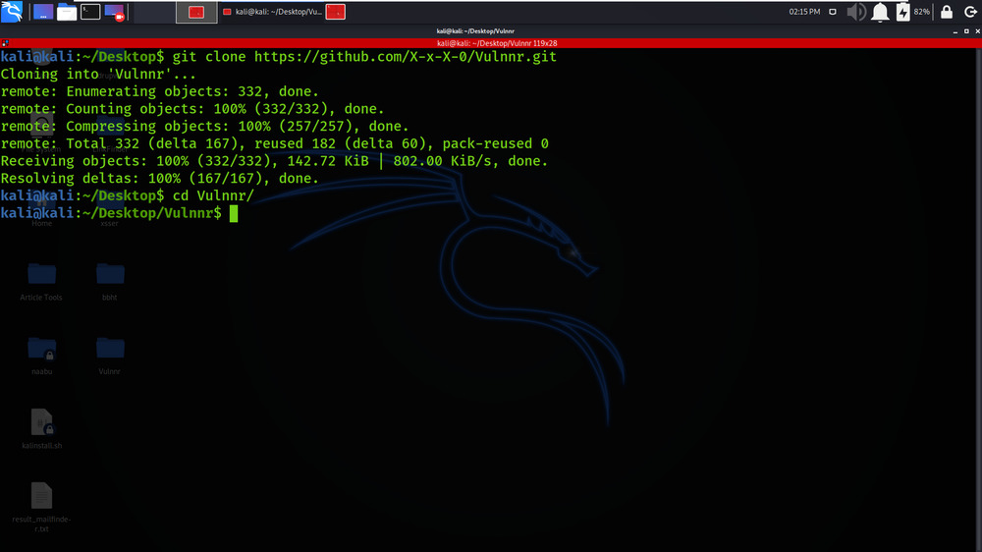



**Vulnerability Path And Parameter Identification**

### Methods For Identifying Vulnerability Paths And Parameters

There are several methods for identifying vulnerability paths and parameters. One method is to conduct a code review, which involves analyzing the source code of an application to identify vulnerabilities. Another method is to use automated vulnerability scanners, which can help identify vulnerabilities and their associated paths and parameters. Additionally, penetration testing and ethical hacking can be used to identify vulnerabilities by attempting to exploit them.

Identifying vulnerability paths and parameters involves several methods and tools to discover potential weaknesses and security issues in applications and systems. Here are some common methods used for this purpose:

1. **Manual Code Review**: Skilled security experts manually review the source code to identify potential vulnerabilities, security misconfigurations, and weak points in the application logic.
2. **Automated Scanning Tools**: Automated vulnerability scanners, like Burp Suite, OWASP ZAP, or Nessus, can crawl through web applications or networks, identifying common vulnerabilities such as SQL injection, Cross-Site Scripting (XSS), and more.
3. **Fuzz Testing (Fuzzing)**: Fuzz testing involves sending random or semi-random input to an application to identify unexpected behaviors or crashes that might indicate vulnerabilities.
4. **Penetration Testing (Pen Testing)**: Ethical hackers simulate real-world attacks to identify and exploit vulnerabilities in a controlled environment, providing valuable insights into potential risks.
5. **Security Headers Analysis**: Inspecting HTTP headers can reveal potential security issues, such as missing or misconfigured security headers like Content Security Policy (CSP) and HTTP Strict Transport Security (HSTS).
6. **Threat Modeling**: By creating a detailed model of an application’s architecture and identifying potential threats and attack vectors, developers can proactively design and implement security measures.
7. **Reverse Engineering**: For certain types of vulnerabilities, like those found in binary applications, reverse engineering techniques can be employed to analyze the compiled code and identify potential weaknesses.
8. **Security Code Analysis**: Automated static code analysis tools, like SonarQube or Checkmarx, analyze source code for vulnerabilities and coding best practices.
9. **Configuration Auditing**: Regularly reviewing and auditing configurations of systems, networks, and applications can help identify security gaps and misconfigurations.
10. **Bug Bounty Programs**: Organizations can incentivize security researchers and ethical hackers to identify vulnerabilities by offering bug bounties for responsibly disclosing security issues.
11. **Secure Coding Guidelines**: Implementing secure coding guidelines during the development process can prevent many common vulnerabilities from being introduced in the first place.
12. **Security Information and Event Management (SIEM)**: SIEM solutions can help identify suspicious activities and potential vulnerabilities by aggregating and correlating security logs and events.

It’s important to note that no single method is comprehensive enough to cover all vulnerabilities, so a combination of approaches is often necessary to achieve thorough vulnerability identification and assessment. Regularly updating software, conducting security testing, and maintaining a strong security posture are key practices for safeguarding applications and systems against potential threats.

### Types Of Vulnerability Paths And Parameters

Vulnerability paths and parameters can vary depending on the type of vulnerability. For example, a SQL injection vulnerability may have a path that involves submitting malicious input to a web form, while a cross-site scripting vulnerability may have a path that involves injecting malicious code into a web page. Parameters can also vary, depending on the type of vulnerability and the specific application being tested. Examples of parameters that may be vulnerable include user input fields, URLs, and cookies.

Vulnerability paths and parameters can vary based on the type of system or application being assessed. Below are some common types of vulnerability paths and parameters that are often targeted by attackers:

1. **Input Validation Vulnerabilities**: These vulnerabilities occur when an application fails to validate user input properly, allowing malicious input to be processed and potentially leading to issues like SQL injection, Cross-Site Scripting (XSS), and Command Injection.
2. **Authentication and Authorization Vulnerabilities**: Weak authentication mechanisms or improper authorization checks can lead to unauthorized access or privilege escalation, enabling attackers to gain unauthorized control over user accounts or system resources.
3. **Insecure Direct Object References**: Insecure direct object references occur when an application exposes internal object references, such as file paths or database keys, allowing attackers to access unauthorized resources.
4. **Business Logic Vulnerabilities**: Business logic vulnerabilities arise when an application’s logic can be manipulated to perform unauthorized actions or access restricted functionality.
5. **Encryption and Cryptography Vulnerabilities**: Weak encryption algorithms or improper cryptographic implementations can expose sensitive data, leading to data breaches or unauthorized data access.
6. **Session Management Vulnerabilities**: These vulnerabilities involve issues with how sessions are managed, leading to session hijacking, session fixation, or session invalidation problems.
7. **Cross-Site Request Forgery (CSRF)**: CSRF vulnerabilities enable attackers to trick users into performing unwanted actions on a different website while they are logged into an authenticated session.
8. **Denial-of-Service (DoS) and Distributed Denial-of-Service (DDoS)**: These attacks target network and application resources, causing service disruptions and making systems unavailable to legitimate users.
9. **Security Misconfigurations**: Misconfigured servers, databases, or application settings may expose sensitive information, increase the attack surface, or create unintended security holes.
10. **Rogue Access Points**: In wireless network security, rogue access points are unauthorized wireless access points that can be used by attackers to intercept communications or launch attacks on connected devices.
11. **Code Injection Vulnerabilities**: Code injection occurs when malicious code is injected into an application, potentially leading to code execution, data leaks, or unauthorized access.
12. **Information Disclosure**: Information disclosure vulnerabilities expose sensitive data, such as error messages or stack traces, that can be used by attackers to gain insight into the system.

It’s important to note that this list is not exhaustive, and vulnerabilities can manifest in various forms depending on the specific system’s design and implementation. Regular vulnerability assessments and security testing are essential to identify and address these vulnerabilities proactively.

### Common Tools And Techniques For Identifying Vulnerability Paths And Parameters

There are a variety of tools and techniques that can be used to identify vulnerability paths and parameters. These include manual code reviews, automated vulnerability scanners, and web application firewalls. Additionally, network sniffing and packet analysis can be used to identify vulnerabilities related to network communication.

Identifying vulnerability paths and parameters involves using a combination of tools and techniques. Below are some common tools and techniques commonly used by security professionals to discover vulnerabilities in systems and applications:

1. **Manual Code Review**: Skilled security experts manually review the source code to identify potential vulnerabilities, security misconfigurations, and weak points in the application logic.
2. **Automated Vulnerability Scanners**: These tools automatically crawl through web applications or networks, identifying common vulnerabilities such as SQL injection, Cross-Site Scripting (XSS), and more. Some popular vulnerability scanners include Burp Suite, OWASP ZAP, and Nessus.
3. **Fuzz Testing (Fuzzing)**: Fuzz testing involves sending random or semi-random input to an application to identify unexpected behaviors or crashes that might indicate vulnerabilities. AFL (American Fuzzy Lop) and Peach Fuzzer are popular fuzzing tools.
4. **Penetration Testing (Pen Testing)**: Ethical hackers simulate real-world attacks to identify and exploit vulnerabilities in a controlled environment, providing valuable insights into potential risks. Tools like Metasploit and Nmap are commonly used in penetration testing.
5. **Static Code Analysis**: Automated static code analysis tools, like SonarQube or Checkmarx, analyze source code for vulnerabilities and coding best practices.
6. **Dynamic Application Security Testing (DAST)**: DAST tools interact with the running application to identify vulnerabilities in real-time. Burp Suite and OWASP ZAP also offer DAST features.
7. **Security Headers Analysis**: Tools like SecurityHeaders.io and OWASP Amass can assess the security headers used in web applications and identify missing or misconfigured headers.
8. **Threat Modeling**: Creating a detailed model of an application’s architecture and identifying potential threats and attack vectors can help developers proactively design and implement security measures.
9. **Reverse Engineering**: For certain types of vulnerabilities found in binary applications, reverse engineering techniques can be employed to analyze the compiled code and identify potential weaknesses.
10. **Configuration Auditing**: Regularly reviewing and auditing configurations of systems, networks, and applications can help identify security gaps and misconfigurations.
11. **Wireless Network Security Tools**: Tools like Aircrack-ng and Kismet can be used to assess the security of wireless networks and identify rogue access points.
12. **Bug Bounty Platforms**: Organizations can engage with security researchers and ethical hackers through bug bounty platforms like HackerOne and Bugcrowd to identify and responsibly disclose vulnerabilities.

These tools and techniques complement each other and play a vital role in a comprehensive vulnerability assessment process. Regularly performing security testing and staying updated with the latest threats and vulnerabilities are crucial for maintaining a robust security posture.

### Best Practices For Vulnerability Path And Parameter Identification

### 

To ensure that vulnerability paths and parameters are identified accurately and comprehensively, it is important to use a combination of manual and automated testing methods. It is also important to test applications in different environments and with different user roles to identify all possible attack vectors. Finally, thorough documentation and reporting of identified vulnerabilities and their associated paths and parameters is crucial for developers to be able to address the vulnerabilities effectively.

Identifying vulnerability paths and parameters is a critical step in ensuring the security of systems and applications. Here are some best practices to follow for effective vulnerability path and parameter identification:

1. **Thorough Testing**: Utilize a combination of manual and automated testing techniques to achieve comprehensive coverage. Manual code reviews and penetration testing complement automated scans to find both common and unique vulnerabilities.
2. **Stay Updated**: Regularly update vulnerability scanners, security testing tools, and threat intelligence sources to ensure they have the latest information about emerging threats and attack techniques.
3. **Comprehensive Scanning**: Perform both static and dynamic analysis of applications to cover vulnerabilities present in the source code as well as those exposed during runtime.
4. **Customization**: Customize vulnerability scanning tools to suit the specific technology stack and application framework used in your organization. This ensures relevant results and reduces false positives.
5. **Validate Findings**: Manually validate the findings from automated scanning tools to confirm the presence and severity of vulnerabilities before remediation.
6. **Focus on High-Risk Areas**: Prioritize scanning and testing efforts on high-risk areas, such as authentication, access controls, input validation, and sensitive data handling.
7. **Threat Modeling**: Conduct threat modeling exercises during the design phase to identify potential paths attackers might use to exploit vulnerabilities.
8. **Test Third-Party Components**: Assess third-party libraries and components for known vulnerabilities and ensure they are up to date.
9. **Implement Secure Development Practices**: Follow secure coding practices, utilize secure libraries, and enforce secure coding standards during the development process to prevent introducing vulnerabilities.
10. **Establish Bug Bounty Programs**: Encourage responsible disclosure of vulnerabilities by running bug bounty programs, rewarding ethical hackers for finding and reporting security issues.
11. **Review Error Handling**: Examine error handling mechanisms to avoid revealing sensitive information or system details that might assist attackers.
12. **Limit User Input**: Validate and sanitize all user inputs to prevent injection attacks like SQL injection and Cross-Site Scripting (XSS).
13. **Utilize Security Headers**: Implement appropriate security headers, such as Content Security Policy (CSP) and HTTP Strict Transport Security (HSTS), to enhance protection against certain types of attacks.
14. **Regular Retesting**: Perform regular security assessments, especially after any significant changes to the system, to identify new vulnerabilities or verify the effectiveness of previous remediation efforts.
15. **Engage Security Experts**: Involve cybersecurity experts with experience in vulnerability assessment and penetration testing to ensure a comprehensive evaluation of your system’s security.

By following these best practices, organizations can identify and address vulnerabilities more effectively, reducing the risk of potential security breaches and ensuring the overall security of their applications and systems.

### Challenges And Limitations Of Vulnerability Path And Parameter Identification

One of the biggest challenges in identifying vulnerability paths and parameters is the constantly evolving nature of vulnerabilities and attack methods. Additionally, some vulnerabilities may be difficult to identify and require specialized knowledge and skills to detect. Another limitation is the potential for false positives or false negatives in vulnerability scanning and testing, which can lead to wasted time and resources.

Identifying vulnerability paths and parameters can be challenging and comes with certain limitations. Here are some common challenges and limitations associated with vulnerability path and parameter identification:

1. **False Positives and Negatives**: Automated vulnerability scanning tools may produce false positives (identifying vulnerabilities that do not exist) or false negatives (failing to detect actual vulnerabilities). This requires manual verification to confirm the findings.
2. **Complexity of Applications**: Large and complex applications may have multiple entry points and paths, making it difficult to identify all possible vulnerabilities accurately.
3. **False Sense of Security**: Relying solely on automated scanning tools without manual validation may give a false sense of security, as some vulnerabilities may go undetected.
4. **Contextual Understanding**: Automated tools may lack the contextual understanding required to accurately assess certain types of vulnerabilities, such as business logic flaws.
5. **Lack of Access to Source Code**: For proprietary software or third-party components, access to the source code may not be available, limiting the depth of analysis.
6. **Threat Evolution**: New and emerging attack techniques may not be covered by existing vulnerability scanning tools, leading to undetected vulnerabilities.
7. **High-Interaction Vulnerabilities**: Some vulnerabilities may require high interaction, making it difficult to detect them through automated scanning alone.
8. **Insecure Configurations**: Automated tools might not be able to identify misconfigurations or weak security settings that lead to vulnerabilities.
9. **Dynamic Environments**: For cloud-based or dynamically changing environments, continuous scanning and adapting tools are required to keep up with the changes.
10. **Time and Resource Constraints**: Identifying vulnerabilities manually can be time-consuming and resource-intensive, particularly for large and complex applications.
11. **Legacy Systems**: Vulnerability scanning tools might not be fully compatible with legacy systems, limiting their effectiveness in identifying vulnerabilities in such environments.
12. **Lack of Documentation**: Incomplete or outdated documentation can hinder understanding application functionality and potential vulnerability paths.
13. **Limited Scope**: Automated tools may have limited scope and may not cover all aspects of the application or system being assessed.
14. **False Sense of Completion**: After automated scanning, there may be a perception that all vulnerabilities have been identified, leading to a lack of further testing or continuous monitoring.

Overcoming these challenges and limitations requires a comprehensive approach that combines automated scanning with manual testing, threat modeling, security expertise, and continuous monitoring. Engaging skilled security professionals and adopting a proactive security posture can help organizations effectively identify and mitigate vulnerabilities in their systems and applications.

**Detailed Instruction For Vulnerability Reproduction**



### Importance Of Providing Detailed Instructions

Providing detailed instructions for reproducing vulnerabilities is crucial for developers to understand the specific steps required to fix the vulnerability. Without detailed instructions, developers may have difficulty understanding the nature of the vulnerability and how to fix it. Detailed instructions also ensure that vulnerabilities are correctly identified and addressed, reducing the risk of future attacks.

Providing detailed instructions is of utmost importance in various contexts, including communication, task execution, and problem-solving. Here are some reasons why providing detailed instructions is crucial:

1. **Clarity**: Detailed instructions ensure clarity in conveying information, reducing misunderstandings and ambiguity in communication.
2. **Accurate Execution**: Detailed instructions enable precise execution of tasks, ensuring that the desired outcome is achieved correctly.
3. **Consistency**: Consistent and detailed instructions help maintain uniformity in processes and workflows, leading to better results and fewer errors.
4. **Efficiency**: Clear instructions save time and effort by minimizing the need for clarification or rework.
5. **Learning and Training**: In educational settings or when training new individuals, detailed instructions help learners grasp concepts and perform tasks effectively.
6. **Troubleshooting**: In technical or problem-solving scenarios, detailed instructions assist in identifying issues and resolving them methodically.
7. **User Experience**: Detailed instructions improve the user experience by guiding users through complex tasks, enhancing satisfaction and reducing frustration.
8. **Risk Reduction**: In safety-critical processes or hazardous environments, detailed instructions mitigate the risk of accidents or incidents.
9. **Compliance and Regulations**: In regulated industries, providing detailed instructions helps ensure compliance with specific standards and guidelines.
10. **Collaboration**: Clear instructions facilitate effective teamwork and collaboration, as team members can align their efforts based on shared understanding.
11. **Clarity of Expectations**: Detailed instructions set clear expectations, which is essential for achieving the desired outcome and meeting predefined criteria.
12. **Documentation**: Detailed instructions serve as documentation for future reference, providing a record of the steps taken and decisions made.
13. **Quality Assurance**: In quality control processes, detailed instructions help maintain consistent standards and ensure products or services meet the required quality levels.
14. **Remote Work and Global Teams**: In distributed work environments or international teams, detailed instructions bridge language and cultural gaps, improving communication and collaboration.

Overall, providing detailed instructions fosters effective communication, improves efficiency, reduces errors, and enhances overall productivity in various personal, professional, and organizational contexts.

### Components Of A Well-Written Vulnerability Reproduction Instruction

A well-written vulnerability reproduction instruction should include a detailed description of the vulnerability, steps to reproduce the vulnerability, and expected outcomes. The instruction  should also include information on the platform or application affected, the severity of the vulnerability, and any potential impact of the business.

A well-written vulnerability reproduction instruction is crucial for security researchers and developers to understand and replicate reported vulnerabilities. Here are the key components of such instructions:

1. **Title and Summary**: Provide a clear and concise title that describes the vulnerability in a few words. Follow it with a brief summary that summarizes the vulnerability’s impact and affected components.
2. **Vulnerability Description**: Describe the vulnerability in detail, including how it was discovered, its root cause, and the potential consequences if exploited. Use clear language and avoid jargon or technical terms whenever possible.
3. **Affected Components**: Specify the exact versions and components of the affected software or system, including relevant configuration details, platforms, and environments.
4. **Steps to Reproduce**: Outline the step-by-step instructions to reproduce the vulnerability, including the necessary inputs, settings, and interactions required to trigger the issue.
5. **Test Environment**: Clearly define the test environment used for the reproduction, including software versions, operating systems, and any specific configurations that might be relevant.
6. **Proof of Concept (PoC)**: Provide a working Proof of Concept (PoC) code or script that demonstrates the vulnerability in action. This code should be concise, well-documented, and self-contained.
7. **Screenshots or Logs**: If applicable, include screenshots or relevant log entries that illustrate the vulnerability and its effects.
8. **Mitigation Recommendations**: Offer suggestions or best practices to mitigate the vulnerability, along with any temporary workarounds if available.
9. **Impact Assessment**: Describe the potential impact of the vulnerability on the system or application, including possible risks and scenarios that may arise if the issue remains unaddressed.
10. **Contact Information**: Include your contact details (email, username, etc.) in case the recipient needs further clarification or has questions about the vulnerability report.
11. **Disclosure Policy**: If the vulnerability is being disclosed responsibly, clearly state any disclosure timelines or restrictions, respecting responsible disclosure practices.
12. **References and Citations**: Include references to any relevant documentation, research, or standards that relate to the vulnerability or its discovery.

Remember, a well-written vulnerability reproduction instruction should be concise, clear, and comprehensive. It should provide enough information for the recipient to understand the issue, reproduce it in a controlled environment, and take appropriate actions to address it.

### Steps For Reproducing Vulnerabilities

The steps for reproducing vulnerabilities typically involve a series of actions or inputs that trigger the vulnerability. These steps must be clearly defined and detailed to ensure that developers can understand and replicate the vulnerability. Additionally, steps for reproducing vulnerabilities should be consistent across multiple systems or environments to ensure that the vulnerability can be identified and addressed in a timely manner.

### Best Practices For Writing Effective Vulnerability Reproduction Instructions

Effective vulnerability reproduction instructions should be clear, concise, and easy to understand. Instructions should be written in plain language and avoid technical jargon. Screenshots or videos can be used to supplement written instructions and provide  
visual aids for developers.

### Tools And Techniques For Verifying Vulnerability Fixes

Tools and techniques for verifying vulnerability fixes may include automated testing tools, manual testing, and code reviews. These methods can be used to ensure that vulnerabilities have been successfully fixed and that no new vulnerabilities have been introduced.

Verifying vulnerability fixes is a crucial step in the vulnerability management process to ensure that identified security issues have been effectively addressed. Here are some tools and techniques that can be used to verify vulnerability fixes:

1. **Re-Scanning with Vulnerability Scanners**: After applying the fixes, re-scan the affected systems or applications using vulnerability scanners like Nessus, Qualys, or OpenVAS. These tools can help detect if the specific vulnerability is still present.
2. **Manual Verification**: Perform manual tests to validate that the vulnerability has been fixed. For example, if the vulnerability was related to improper authentication, try to access the system with unauthorized credentials to verify that access is now restricted.
3. **Code Review**: If the vulnerability was identified in the source code, perform a code review to ensure that the necessary changes have been made, and potential issues have been addressed.
4. **Regression Testing**: Conduct regression testing to ensure that the fixes did not introduce new vulnerabilities or cause unintended consequences in other parts of the system.
5. **Penetration Testing**: Engage in penetration testing to evaluate the system’s security post-fix and validate that the vulnerability is no longer exploitable.
6. **Exploit Verification**: If the vulnerability was publicly disclosed or known to attackers, verify that the previously exploitable vectors no longer work.
7. **Use Case Scenarios**: Test the system under various use case scenarios to ensure that the vulnerability fixes do not hinder normal system functionality.
8. **Log Analysis**: Monitor system logs to identify any unexpected behavior or anomalies that might indicate the presence of residual vulnerabilities.
9. **Peer Review**: Engage security experts or a dedicated red team to conduct a peer review of the fixes and assess their effectiveness.
10. **Configuration Review**: Review system configurations to confirm that the appropriate security settings have been implemented as part of the vulnerability remediation.
11. **Vendor Confirmation**: If the vulnerability was reported to a third-party vendor, seek confirmation from the vendor that the issue has been resolved in the latest patch or update.
12. **User Testing**: Involve end-users or stakeholders in testing the system after the fixes to verify that the application or service functions as expected.

By employing a combination of these tools and techniques, organizations can ensure that vulnerability fixes have been successfully implemented and that the system’s security posture has been improved. It is essential to follow a systematic and thorough approach to verify the effectiveness of the remediation process and minimize the risk of recurrent vulnerabilities.

### Challenges And Limitations Of Vulnerability Reproduction Instruction

Challenges and limitations of vulnerability reproduction instruction may include differences in system configurations or environments, difficulty in replicating complex vulnerabilities, and the need for access to source code or proprietary systems. It is important to address these challenges to ensure that vulnerabilities are accurately identified and addressed.

**Comprehensive And Detailed Reporting**

### Importance Of Comprehensive And Detailed Reporting:

Comprehensive and detailed reporting is crucial for businesses and organizations to make informed decisions. It involves analyzing and presenting data in a clear and concise manner, which helps stakeholders to identify patterns, trends, and potential problems. Comprehensive and detailed reporting provides an accurate picture of an organization&#39;s operations, financial performance, and overal health, which can be used to guide strategic planning and resource allocation.

### Key Components Of Comprehensive And Detailed Reporting

Key components of comprehensive and detailed reporting include accurate and relevant data, effective data analysis, clear and concise presentation of findings, and actionable recommendations. The report should be well-organized, easy to understand, and tailored to the audience's needs. It should also provide context for the data presented, such as benchmarking against industry standards or historical data.

Comprehensive and detailed reporting is essential for conveying complex information effectively and facilitating informed decision-making. When it comes to security-related reporting, the following key components should be included to ensure clarity and completeness:

1. **Executive Summary**: Provide a concise overview of the report’s findings, highlighting the most critical vulnerabilities and their potential impact on the organization. This section should be easily understandable by non-technical stakeholders.
2. **Introduction and Objectives**: State the purpose of the report, the scope of the assessment, and the specific objectives of the security evaluation.
3. **Methodology**: Explain the methodologies and tools used to conduct the assessment, including any manual testing or third-party assessments involved.
4. **Summary of Vulnerabilities**: Present a summary table or list of identified vulnerabilities, including their severity, affected systems/components, and status (fixed, in progress, or unresolved).
5. **Detailed Findings**: Provide comprehensive details for each identified vulnerability, including a clear description, affected systems, root cause analysis, and any recommended fixes.
6. **Proof of Concept (PoC)**: Include PoC code or step-by-step instructions for exploiting each vulnerability, which helps developers understand the real-world impact.
7. **Risk Assessment and Impact**: Evaluate the risk associated with each vulnerability based on factors like severity, likelihood of exploitation, and potential consequences.
8. **Mitigation Recommendations**: Offer specific recommendations for addressing each vulnerability, including best practices and guidelines for remediation.
9. **Fix Validation**: Describe the steps taken to verify the effectiveness of the vulnerability fixes and the results of the verification process.
10. **Recommendations and Prioritization**: Prioritize vulnerabilities based on their potential impact and provide an action plan with recommended steps for remediation.
11. **Technical Details**: Include technical details, such as vulnerability IDs, CVSS scores, CWE numbers, and any relevant references or external resources.
12. **Appendices**: Include additional supporting information, such as detailed scan results, log files, network diagrams, and any other data that supports the findings.
13. **Conclusion**: Summarize the overall assessment, reiterate the most critical findings, and emphasize the importance of addressing the identified vulnerabilities.
14. **References**: Cite any external sources, standards, or industry best practices referenced during the assessment.

A well-structured and detailed report enhances communication between stakeholders, supports decision-making processes, and provides a foundation for addressing security concerns effectively. It is essential to tailor the report to the intended audience, ensuring that both technical and non-technical readers can understand the information presented.

### Strategies For Effective Reporting

Strategies for effective reporting include identifying the purpose and scope of the report, understanding the audience's needs, selecting appropriate data sources and analysis techniques, and using clear and concise language to present findings. The report should be well-organized, visually appealing, and use data visualization tools to help the audience better understand the data.

### Challenges In Implementing Comprehensive And Detailed Reporting

Challenges in implementing comprehensive and detailed reporting include data quality issues, data silos, lack of resources,  
and difficulty in identifying the right metrics to measure. Organizations also face challenges in presenting data in a way that is easily  
digestible for different stakeholders, such as executives, managers, and frontline employees.

### Impact Of Comprehensive And Detailed Reporting On Decision- Making

Comprehensive and detailed reporting can have a significant impact on decision-making by providing stakeholders with the information they need to make informed decisions. It can help identify areas for improvement, highlight potential risks, and guide  
resource allocation. By providing a comprehensive view of an organization's operations, financial performance, and overall health, stakeholders can make more informed decisions that align with their strategic goals.

### Best Practices For Creating Comprehensive And Detailed Reports

Best practices for creating comprehensive and detailed reports include defining the purpose and scope of the report, selecting  
appropriate data sources and analysis techniques, using clear and concise language to present findings, and including actionable  
recommendations. The report should be well-organized, visually appealing, and tailored to the audience's needs. It should also  provide context for the data presented, such as benchmarking against industry standards or historical data.